**Project Report**

on

**Smart Waste Management System**

**Abstract**

**The Smart Waste Management System Android App is designed to modernize waste collection and reporting through a mobile-based solution. Citizens can easily report waste accumulation by submitting complaints with photos and GPS location using Google Maps integration. The admin can view all complaints, assign cleanup tasks to sanitation workers, and track their status in real time.  
Built using Android Studio (Java), Firebase, and Google Maps API, the app ensures fast, secure, and transparent communication between citizens and municipal authorities. This project promotes community participation and sustainable urban cleanliness using smart technology.**

**Introduction**

* Problem statement

To develop an Android-based Smart Waste Management Application that enables citizens to report waste issues via photo and GPS-based complaint submission, allows municipal authorities to assign tasks to workers, and provides real-time tracking, analytics, and reporting to improve waste management efficiency.

* Objectives
  + To simplify waste complaint reporting using GPS and photo upload.
  + To allow real-time tracking of complaint status.
  + To provide an admin dashboard for worker task assignment and data analysis.
  + To generate area-wise waste reports and heatmaps.
  + To send notifications and feedback requests for transparency.
* Scope and significance

This Android-based solution will help **citizens**, **sanitation workers**, and **municipal officers** coordinate more effectively. It reduces manual paperwork, enables data-driven decision-making, and encourages civic participation. Future versions can integrate **AI-based image recognition** and **IoT smart bins** for predictive waste monitoring.

**Software Requirements**

* Functional requirements

1. User Registration and Login (Citizen, Worker, Admin roles)
2. Complaint Submission with description, image, and GPS location
3. Live Google Map view showing complaint markers
4. Complaint Status Tracking (Pending, In Progress, Resolved)
5. Worker Assignment by Admin
6. Real-time Notifications for updates
7. Feedback and Rating module
8. Report and Heatmap generation for analytics
9. Admin Dashboard for performance monitoring

* Non-functional requirements (reliability, scalability, security, usability)

|  |  |
| --- | --- |
| **Attribute** | **Description** |
| **Reliability** | App should run continuously with minimal downtime. |
| **Scalability** | Supports multiple wards, cities, and growing data load. |
| **Security** | Firebase Authentication to ensure authorized access. |
| **Usability** | Clean, responsive UI suitable for all users. |
| **Performance** | Quick loading, fast location tracking, optimized database calls. |
| **Maintainability** | Modular structure for easy updates. |

* Software & Hardware requirements

**Software Requirements:**

* Android Studio (latest version)
* Java / Kotlin Programming Language
* Firebase Realtime Database / Firestore
* Google Maps API Key
* Glide Library for image handling
* Retrofit for API communication

**Hardware Requirements:**

* Android smartphone (Android 8.0 or higher)
* Minimum 4 GB RAM and Internet connectivity
* GPS-enabled device for accurate location tagging

**Major Functionalities**

1. **User Authentication**

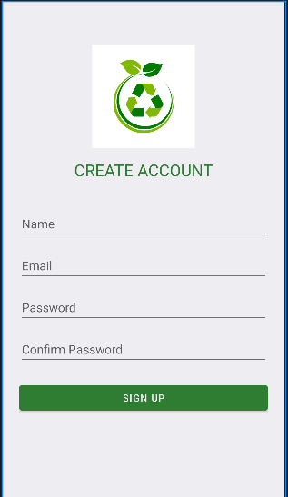

1. **Complaint Submission**

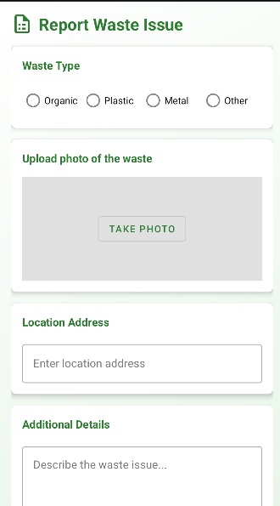

1. **Admin Dashboard**

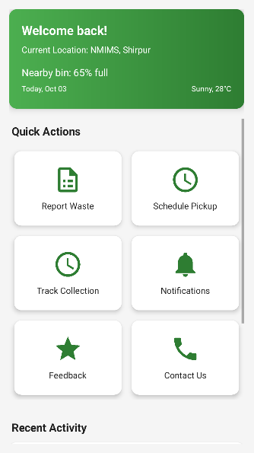

1. **Feedback Module**

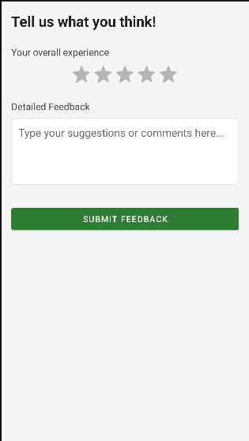

1. **Contact Us Module**

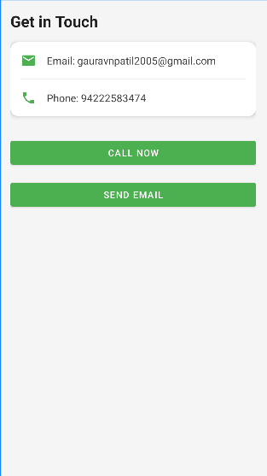

**Conclusion and Future Scope**

**Conclusion**

The **Smart Waste Management Android App** offers an efficient and transparent platform for citizens and authorities to collaborate on improving city hygiene. Through real-time reporting, GPS tracking, and automated notifications, it significantly reduces response time and enhances accountability in waste collection services.

**Future Scope**

* Integration with **IoT smart bins** to track waste levels automatically.
* Implementation of **AI-based waste detection** using image processing.
* Addition of **multi-language support** for accessibility.
* Integration with **UPI payment system** for public cleanliness donations.
* Predictive analytics for identifying recurring waste zones.